João Henrique R Teixeira – 3DS

VIEWS



ROUTE

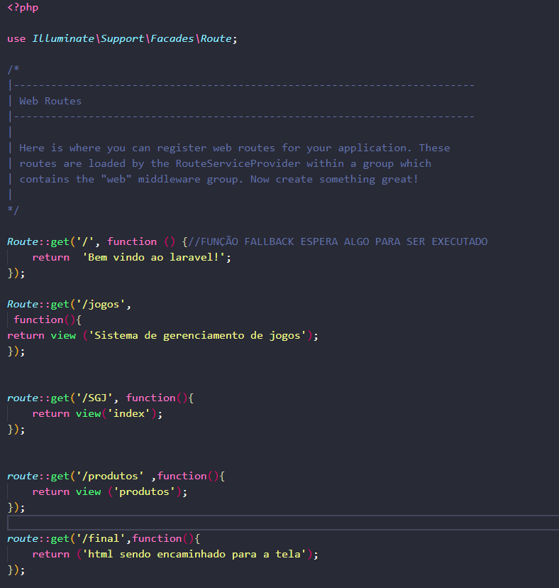

Prompt de comando

